Ideation Phase
Define the Problem Statements

Date | 31 January 2026
Team ID | LTVIP2026TMIDS87294
Project Name | ResolveNow: Your platform for online complaints
Maximum Marks | 2 Marks

Problem Statement -1:
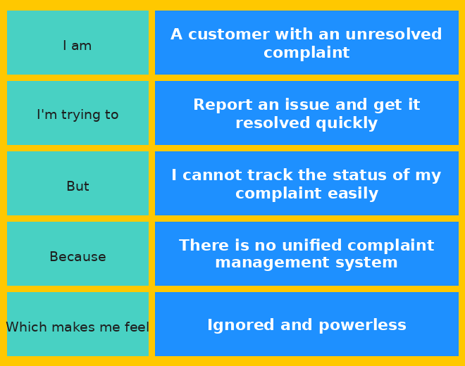
Problem Statement -2:
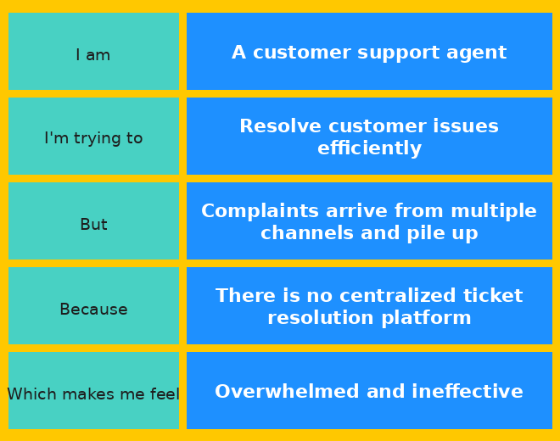
Problem Statement (PS) | I am | I'm trying to | But | Because | Which makes me feel
PS-1 | A customer | Report an issue and get it resolved quickly | I cannot track the status of my complaint easily | There is no unified complaint management system | Ignored and powerless
PS-2 | A support agent | Resolve customer issues efficiently | Complaints arrive from multiple channels and pile up | There is no centralized ticket resolution platform | Overwhelmed and ineffective

